**Project – Online Library Management System**

**Team 02**

**Team Names** – Hemraj Yadav, Mustafa Alsaegh

1. **Conceptual Diagram / Schema Diagram**

Below is visual representation of database structure from our project sqlite database which helps to understand the relationship between entity, attributes, constraints and objects in order to design and maintain databases efficiently and to develop complex queries.

This conceptual diagram is consisting of several elements like

**Tables** - Represent a collection of related data.

**Rows** - Represent actual data store in table.

**Columns** - Define the structure of data in a table.

**Primary key** - Key which uniquely identify each row in a table.

**Foreign Key** - columns that reference the primary key of another table.

**Relationships** - How the tables in DB are related to each other.

**Constraints** - Rules that govern the data store in a table.

**1.1 Tables**

Below are the tables from our project database. We are using Django a Python based web framework to build our web application with sqlite database. It has built in user authentication and therefore, below are couple of tables being used for user management, authentication, authorization, and application content management. The library issued book is what will referenced to book repository.

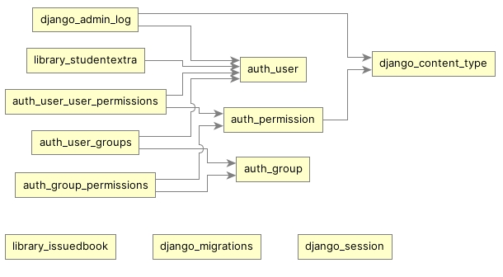

**1.2 Database Schema Diagram**

There is total 13 entities in this database and below diagram shows how they are connected to each other using primary and foreign keys and what is data type for each attribute. Some of the entity details are as below.

Auth_user – It has different data type for different attributes. It is an entity consisting of user login details to the application. It is used to define the user characteristics like first name, last name, join date, email, password, user state, and user permission level.

Auth_group - It is of VARCHAR type which provide the name of group user is member of.

Auth_group_permissions – it is INTEGER type which provides the details on what group is having what permission for authorization.

Library_issuedbook – It is of VARCHAR and DATE data type carrying the information about book issuance details.

Library_book – It is of VARCHAR data type having the information about the book in library repository.

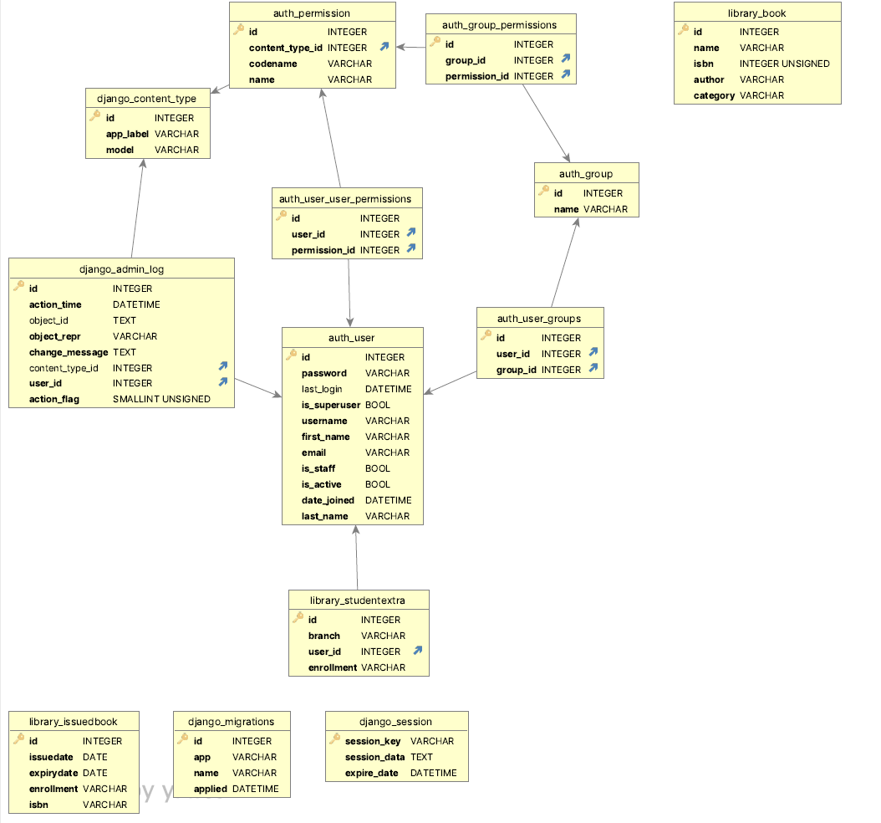

* 1. **Primary Keys:**

Below diagram shows the primary key in each table and the relationship based on the keys

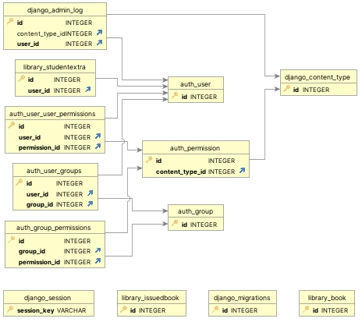

**1.4 Users Auth, Students and Library books:**

Below is another view of users, student enrollment and library book

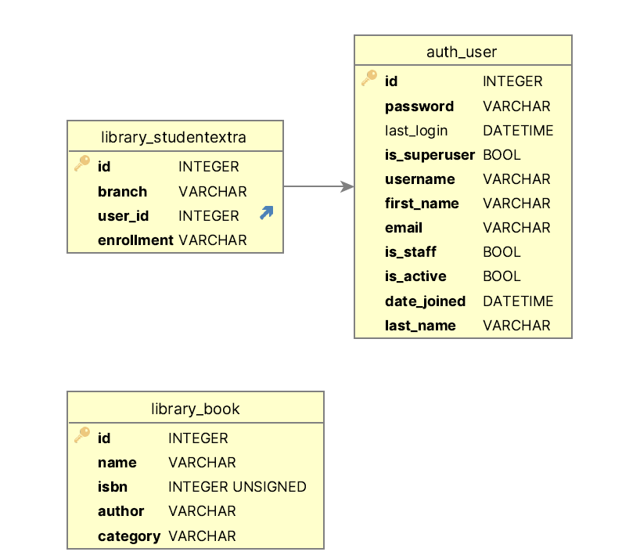

1. **Database constraints**

Constraints are the rules that are applied to one or more columns of a table to enforce business rules or data integrity rules. Constraints are to ensure the accuracy, consistency, and reliability of the data stored in a database. There are different types of constraints like Primary Key constraint, Foreign Key, Unique constraint, Check constraint, Not Null constraint.

We have used below constraint in our project database to ensure the integrity of our data in database.

* Check constraint
* Nullable Constraint
* Unique Constraint
* Foreign Key constraint

**Check Constraint**

Table Constraint

Django_admin_log “action_flag” >=0

Library_book “isbn” >=0

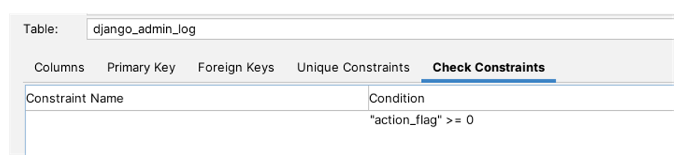

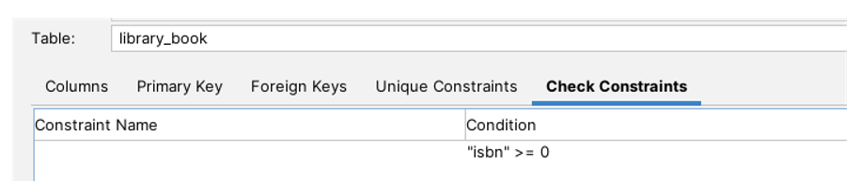

**Nullable Constraint**

Table Constraint

Django_admin_log object_id , content_type_id

auth_user content_type_id , last_login

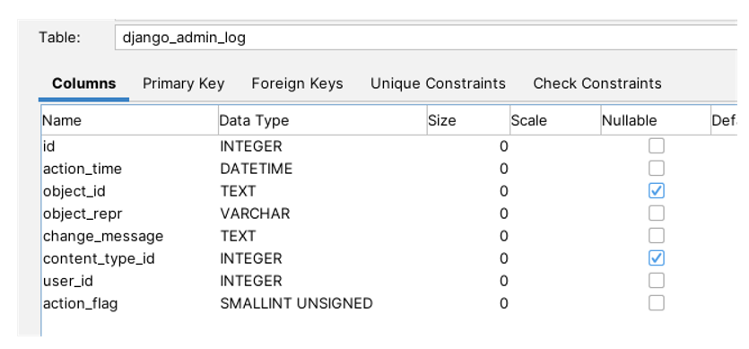

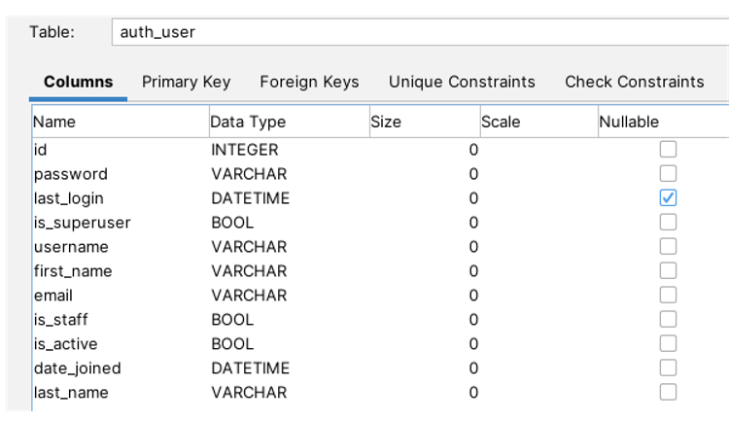

**Unique Constraint**

Table Constraint

auth_group name

auth_user username

library_studentextra user_id

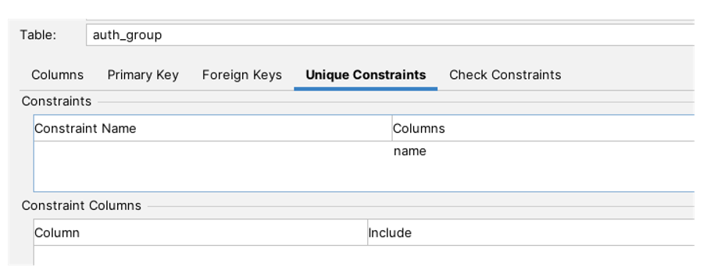

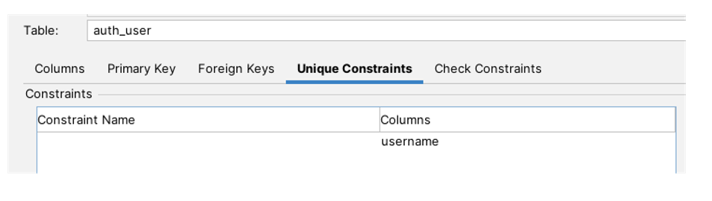

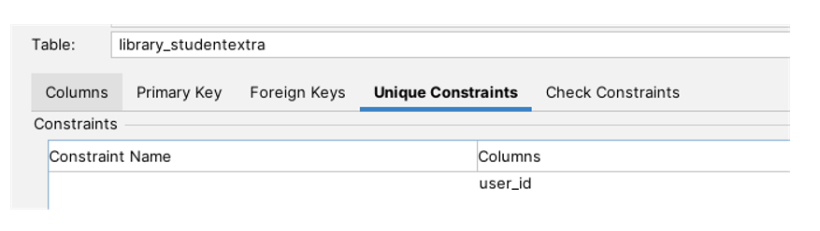

**Foreign Key Constraint**

Table Constraints

Auth_group_permission group_id , permission_id

Auth_permission content_type_id

Auth_user_groups user_id , group_id

Auth_user_user_permissions user_id , permission_id

Django_admin_log content_type_id , user_id

Library_studentextra user_id

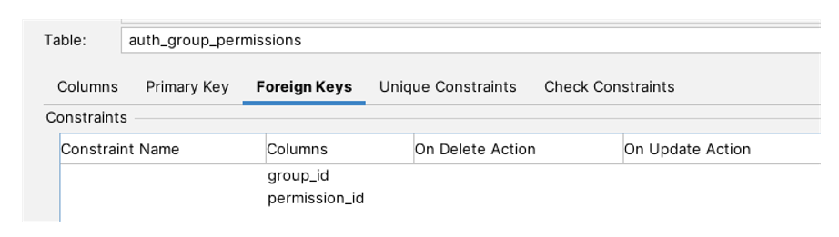

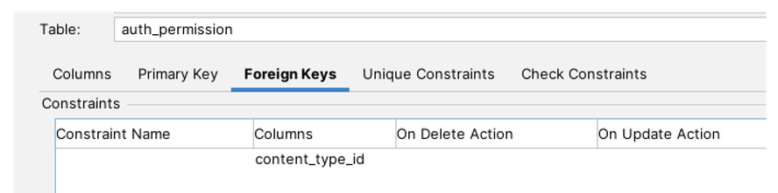

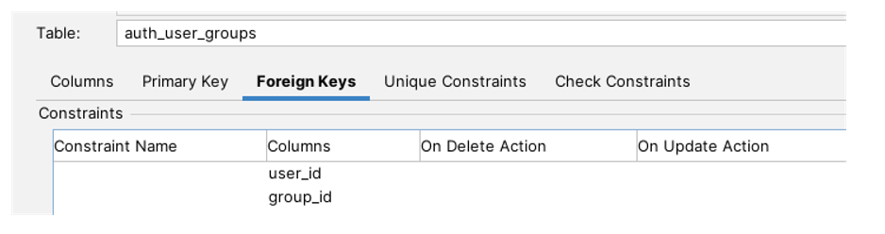

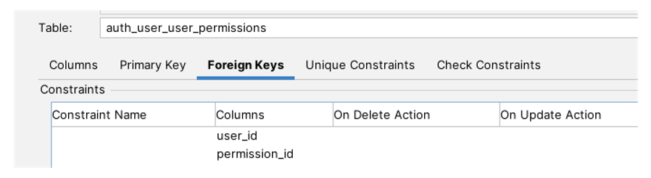

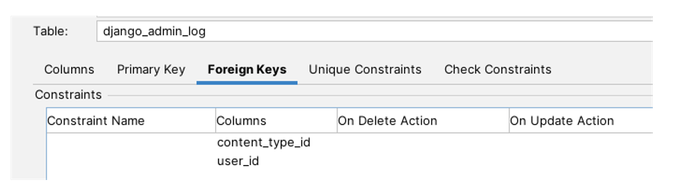

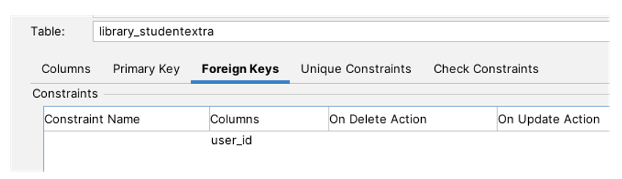

1. **Build Database and Queries**

See attached PDF file *SQL_Code.pdf on* Canvas

1. **Team Member Assessment**

Hemraj: We still do have opportunity to improve time commitment, database code and conceptual schema.

Mustafa: I think we managed time effectively and completed the tasks within the given time frame. Our Conceptual Schema identifies all the necessary entities and their relationships, but as for our database it does need optimization, using appropriate indexing, partitioning, and clustering techniques. The code is functions good, data insertion and retrieval operations working as expected, but there is space for improving.